Minutes
Elizabeth-Kitley Public Library Board
In Attendance: Henry Oosterhof, James Laverty, Bruce Brownell, Robert Elston, Ashley Rankie
Regrets: Terry James
Staff Present: Ruth Blanchard
This meeting was held at the Main Library Branch, 4103 County Road 29
Call to Order: Acting Chair Laverty called meeting to order at 7:03
Adoption of the Agenda
Moved by: R Elston
Second by: B. Brownell
That the Public Library Board Agenda for February 18th be adopted.
Disposition: Motion Carried
Conflict of Interest: There was no conflict of interest declaired
Adoption of the minutes:
Moved by: B. Brownell,
Second by: H. Oosterhof
That the Public Library board minutes dated from January 21, 2026 meeting be adopted.
Disposition: Motion Carried.

Business Arising from the Minutes:
Follow up on Lyn Computers and computer contract issues:
We will pick a date and assemble some library board members and staff to discuss the issues the library is experiencing with our computers.
Follow up with building maintenance:
The light in Kitley should be fixed by the end of the month. The light at the road is owned by Ontario hydro and they will be replacing it.
Follow up on carpets:
C. Dowell has quotes for the carpets, as well as the bathroom, awaiting approval.
Follow up library cards:
The staff have proposed making a card on paper that is laminated. They will make some mock ups for the next meeting to show the board. A. Rankie will find out how much getting cards made professionally would cost as well, just for options.
Follow up on A.V. equiptment:
In order to get new A.V equipment in the library this year we would need to fundraise for it. One suggestion is that the car show we host, we could request the car exhibitors could donate $5.00 to our AV equipment fundraiser. It was also suggested we ask C.Dowell to look for grants for technology.
Follow up on Feb 12th budget presentation:
Acting Chair Laverty presented our budget to the E-K council and we will find out the results on the 23rd of February.
Bylaws – review:
The board has been presented with the EK Public Library Board Bylaws. The board members will read them over and discuss them over the next couple meetings.
Training for the board members:
No progress on this currently, because it had to take a back seat to the budget for the past month.

Correspondence
We received a letter from Battle River Energy with a donation of 12.88.

Financial Report
The financial report does not show that we received the provincial grant ($19,452.00) and the connectivity grant ($2,692.00), but we did receive it.

CEO Report
Tween program is a big success. It is help at the main branch and fills up.
To see more information on programs, see below.
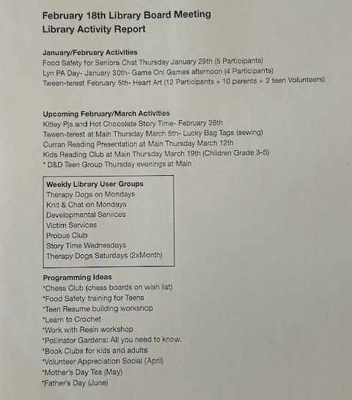

New Business:
-A. Rankie brought up that while looking up stats for the budget, she discovered that the stats for library card holders is around 6 or 7% of residents. She suggested that when we launch our new library cards we make a push to get more people to sign up for a card, potentially with a contest.
-H.Oosterhof wanted to show the board a library receipt from another library that shows all the books and cost saved. A. Rankie will look into the cost and logistics on how we could do this.

Round Table:
- Access to previous minutes: We do not have any minutes available to the public for the last few years. We are trying to remedy this problem.
- Marketing strategy: We need to start considering different ways to get the word out to the community about what our services and programs.
- Website: Our website is lacking and we need to consider rebuilding from scratch. The board would like to direct staff on looking into the cost of a new website and the logistics of what it would take to operate it.
Adjournment:
Moved by A Rankie
Second by Acting Chair Laverty
That the meeting be adjourned at 8:19 and to meet again on March 18th2026 at the Spring Valley Branch.
Disposition: motion carried.

