Elizabethtown-Kitley Library board Agenda
January 21 2026
Spring Valley Branch
In Attendance: Henry Oosterhof, James Laverty, Terry James, Bruce Brownell, Robert Elston, Ruth Blanchard, Ashley Rankie, Heidi Adcock, Amy Way
Nominations for the Chair:
Moved by Rob that Ed remains as Chair, seconded by Bruce.
Carried
Nominations for the Vice Chair:
James has stepped forward to be vice chair, second by Ashley
Carried.
Nominations for Secretary
Bruce nominated Ashley to remain secretary, Terry second.
Carried.
Nominations for treasurer Henry nominated Charles Dowdell, seconded by Terry.
Carried.
Call to Order: 7:23

Adoption of the Agenda:
Motion to accept the Agenda.
Moved by Bruce, Second Henry.
Carried.
Conflict of Interest: n/a
Adoption of the minutes from December 2025
Motion to accept by Henry, Second Terry.
Carried.

Business Arising from the Minutes:

Updates on computers in Lyn
No movement on this issue of of the time of this meeting. The issue with software and e-mails have not been solved, nor have the questions regarding billing been answered.
One of the main issues is that the staff are having trouble with is their e-mails and despite every effort made, there has not been any resolution.
Motion for the staff to compile their issues into a document that they will send to Ashley to send to Charles to be addressed.
Moved by Bruce, Second terry
carried

Updates on desk/lights/carpets
Ruth has spoken to Building maintenance manager about the issue, and he is looking into the light at the end of the driveway to see if the power has been shut off to it.
The request to replace the desk and carpets is awaiting budget approval. A Maintenance staff member has been in to get measurements.

Memorandum of Understanding
The board received a copy of the M.O.U to sign. It was signed by James, as the acting chair, and Ashley as the secretary.

Training for Library board
Motion to request Charles send us links for training for board members.
Moved by Bruce, Second by Ashley
Carried

Correspondence
None this month

Financial Report
No financial report was presented this month.

CEO Report
Ruth presented the board with a list of programs this month and upcoming. Programs include pajama story time, tween programming and upcoming programs will include food safety and handling workshops.
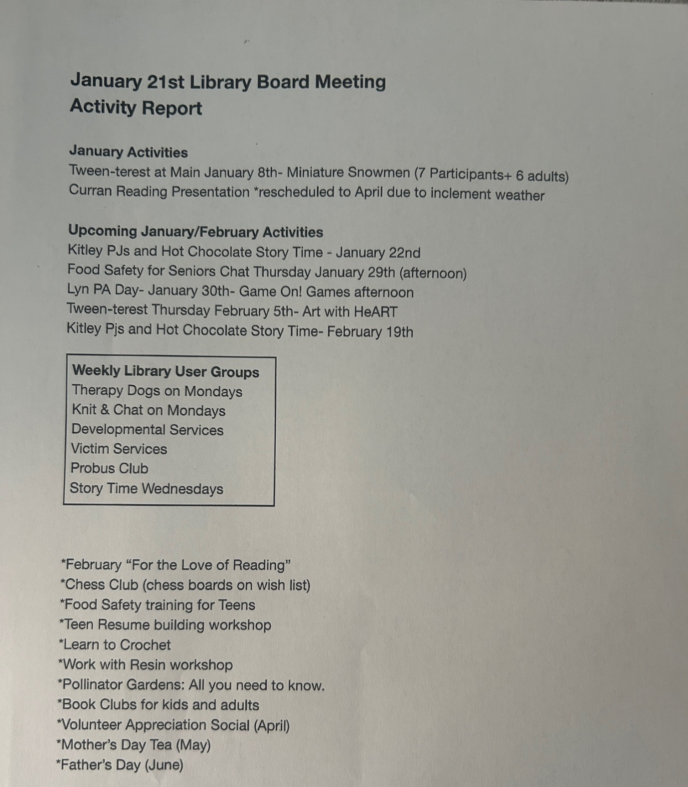

New Business:

Bylaw for the board
The board discussed creating a EK library board operating bylaws.

Discuss Feb 12, special meeting for budget deliberations
February 12th is when the township discusses the budget and looks at the requested budgets from different entities. The acting Chair and CEO will attend.
Acting vice chair requested the secretary to provide financial stats from the province regarding municipal funding. Ashley will e-mail that information to James prior to the February 12th meeting.
Date of meeting is February 12 at 6:00 pm at the New Doublin office.

Round Table:

A.V. for the library
James has proposed we look into purchasing some AV equipment. The board will look into creating a proposal for this initiative.

Library Cards
The topic of library cards was brought up a few months ago, and we would like to circle back on this. Staff will look into this.
Adjournment: 8:48
February 18th 7:00 at the Spring Valley

